**Custom Customer Relation Management (CRM) System**

**Introductory**

As part of the process to improve the workflow of our client’s daily operations, we require an CRM to facilitate a central means managing, tracking and recording. This product will cove several aspects of business services. For this CRM, the application will be for a Hearing Aid Company. They would diagnose the Customer’s condition and prescribe the appropriate hearing aid product. They would then service the Customer then onwards.

**Workflow of Customer**

Diagram attached below is the workflow of the customer.

Customer walks-In

Customer self-registers at the reception counter

Specialist sees the customer and fills a form by asking a set of questions.

Specialist prescribe the next-course of action and assigns task to counter staff.

Customer pays at the counter and schedules next apt. [New Customer: 2 week; Existing Customer: 6Months]

**Users Tier**

**Customer:** Able to login to the portal to see the Rewards/Points System.

**Staff/Specialist:** Able to do create, update & delete Customer records, Generate Invoices, Schedule Appointments.

**Admin:** Able to see Accounting Dashboard, Sale, Owing & Revenue. Able to manage users and points conversions.

**High Level Requirements**This part will specify the details on the features. Refer to the wireframe screens for reference.

|  |  |  |
| --- | --- | --- |
| User | Requirement / Feature | Objective |
| Customer | Customer Self-Register | Customer can Self-Register at the reception counter on a tablet. |
| In-House | Customer Information Logging | The Staff/Specialist can create, update & delete Customer information.   Specialist ask a set of questions. This can be a form with check boxes/dropdown options. |
| In-House | Timeline | Activities are logged in the form of timeline, so the Staff can see the history of the Customer. |
| In-House | Products | After understanding the condition of the Customer, the Specialist will prescribe the appropriate the hearing aid device the Customer requires. |
| In-House | Task* | Each Staff/Specialist has their own account which can assign or receive task to be done. |
| In-House | Calendar | The Staff can schedule the following appointment on the CRM calendar which is synced to Google Calendar.  The calendar is the main screen the Staff/Specialist see when they login. They can view by Month/Week/Day. |
| In-House | Invoicing | The Staff can generate and print the invoice.  The Customer may wish to pay either Cash/Credit Card/Cheque.  The invoicing feature works with the Wave API. ([Ref link to API Doc](http://docs.waveapps.io/endpoints/invoices.html)) |
| In-House & Customer | Points/Rewards System* | Upon payment, the CRM can convert the sale amount to points for the Customer.  The conversion rate of cash-to-points can be edited by the Admin.  The Customer will have a portal to login and check how many points they have generated. Also shows what they can offset them for. |
| Customer & Admin | Customer Satisfaction* | Customer can rate the experience he/she had at the clinic upon payment.  Admin is able to see the level of service rendered at each shop. |
| In-House | Search | The Staff/Specialist can do a quick search by entering the Customer’s NRIC/Name/Phone No. |
| In-House | Black-listing | The Staff can indicate (Checkbox) a Customer as a Blacklisted. A colour label in the search can indicate if the Customer has been blacklisted. |
| Admin | Accounting | With the access to Wave API, the Admin is able to see the overview/specific earnings, Owings & revenue for the month/week/day. ([Ref link to API Doc](http://docs.waveapps.io/endpoints/accounts.html)) |

*Note: No screen was generated for this, however please use the overall theme as the baseline.

**Screens**

This section will explain each screen in detail of the Client & Customer end. All images are attached in the email for clearer viewing.

Customer Self Register

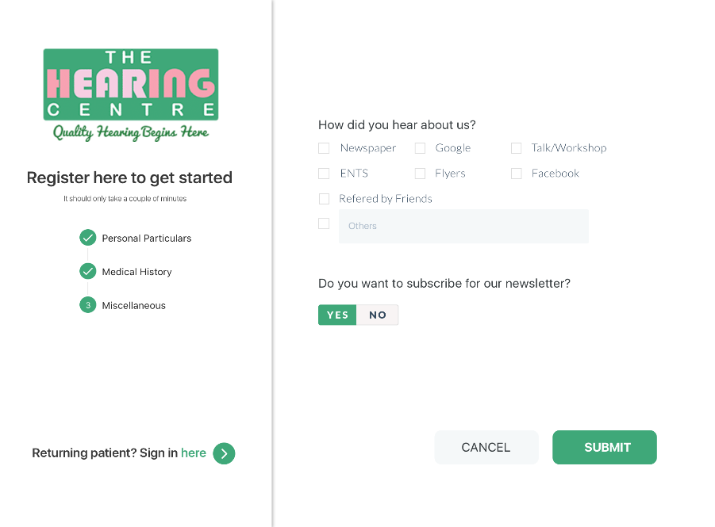Upon arriving to the clinic, the *New Customer* is to self-register themselves where they will fill up a set 3 step questionnaire.   
  
*The 2nd step questions will be sent soon.*

This will be done on a touch device via web browser.

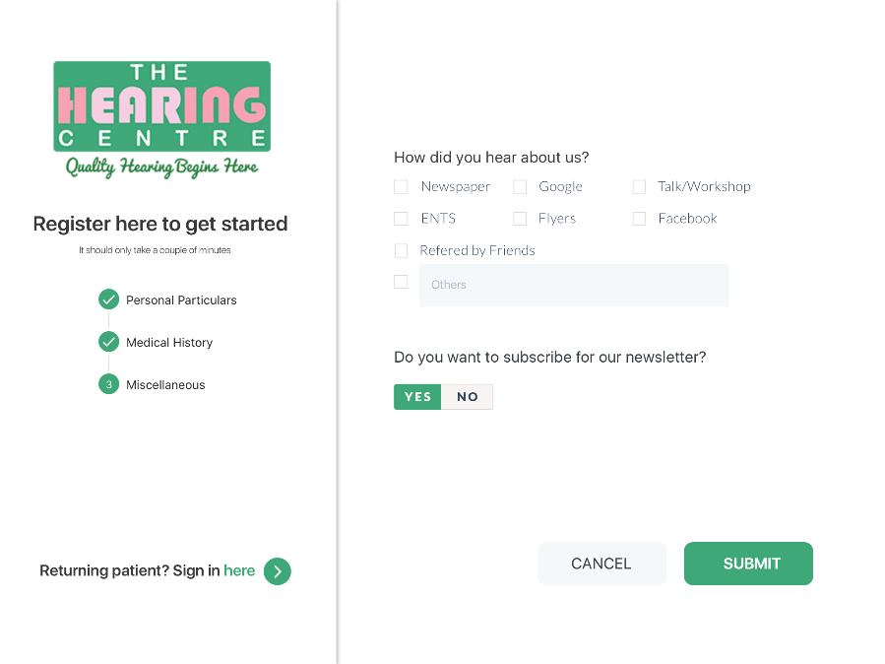

Part of the steps will include a question set for the customer to enter how they found the clinic.

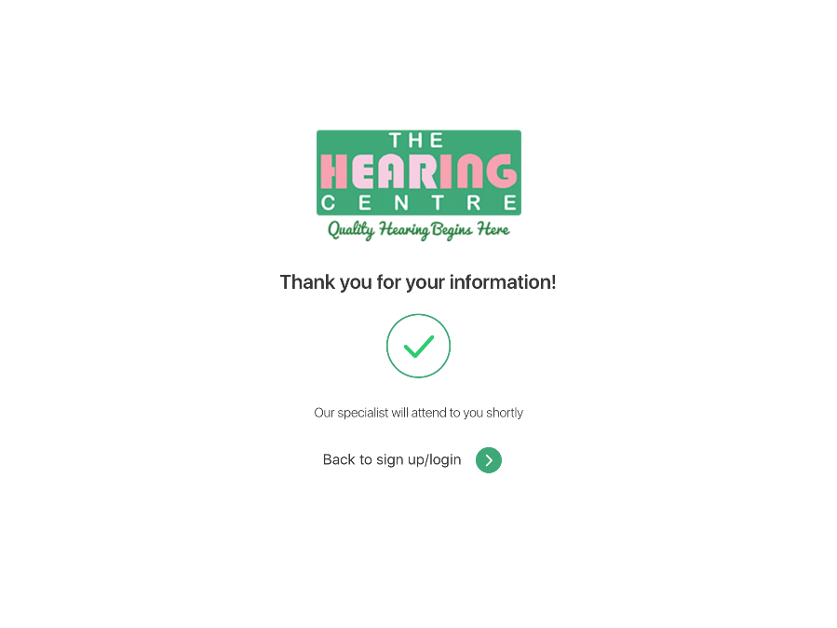Upon submitting, they will see a success screen. Where they will be registered to the database.

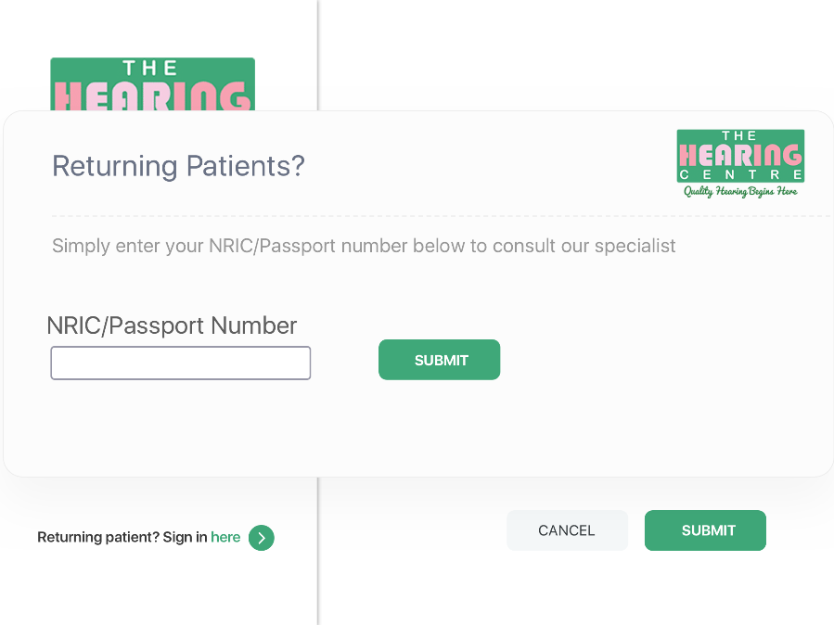

Returning Customers will simply enter their NRIC to register to the queue. This field is an auto-suggestion to minimize time spend at the counter.

Staff/Specialist/Admin Area

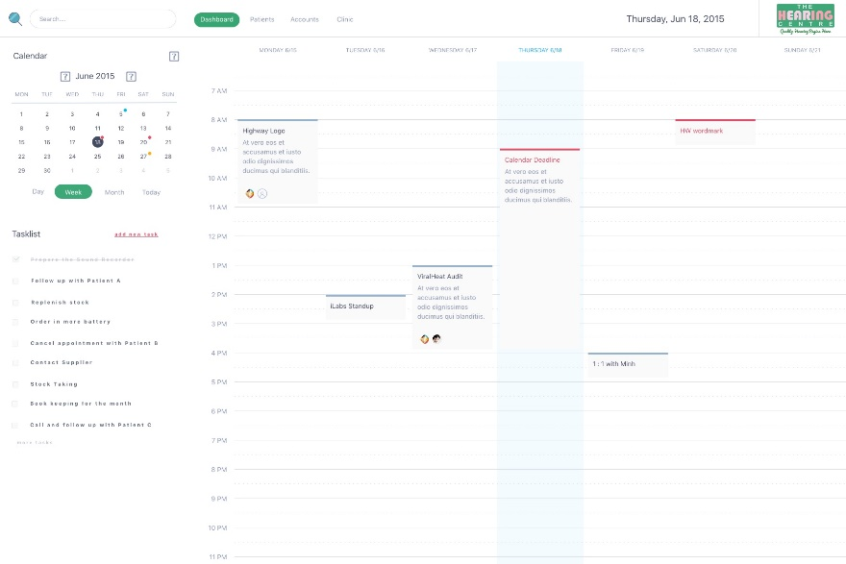After the Staff/Specialist login, they will see the above screen, a calendar view of the appointments. On the top-left, they can toggle between Day/Week/Month. Below that is the list of task they have been assign to. The menu bar can toggle between screens. The top right corner will consist of the company logo.

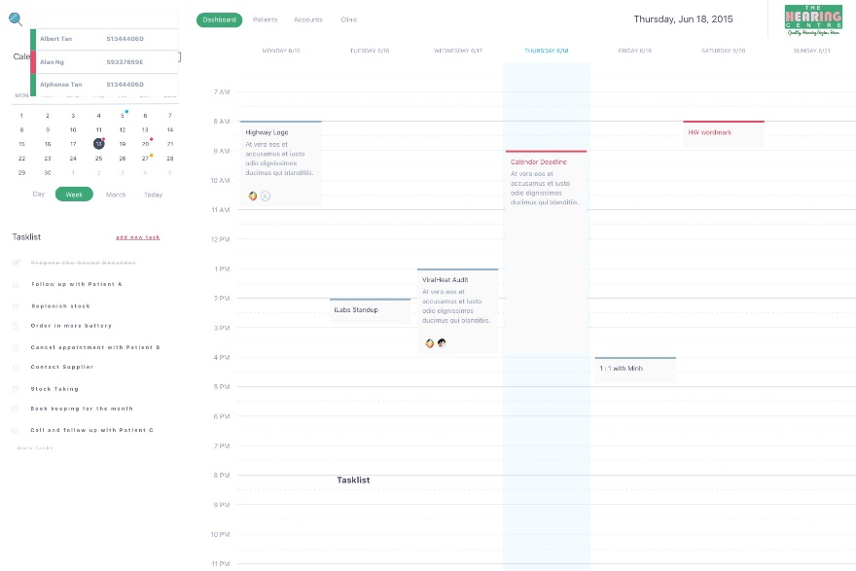Staff/Specialist can search for Customer information base on NRIC/NAME/TEL and they would see the Customers. The colour labelling indicates as such; Green – Customer, Red – Blacklisted, Blue – Leads(Potential Client). This search function is Auto-Suggestive.

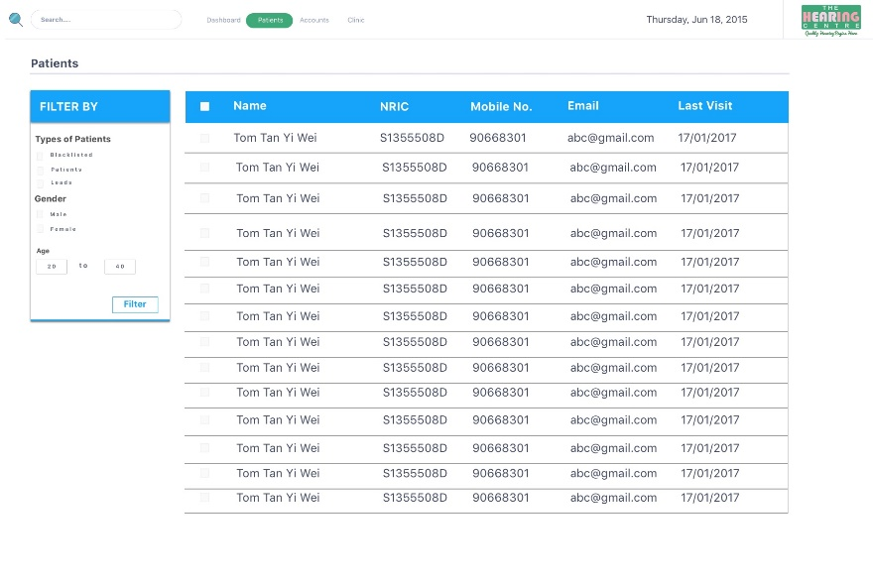Search results will show an overviews with the following critical information and allows for further filtering options.

Staff/Specialist 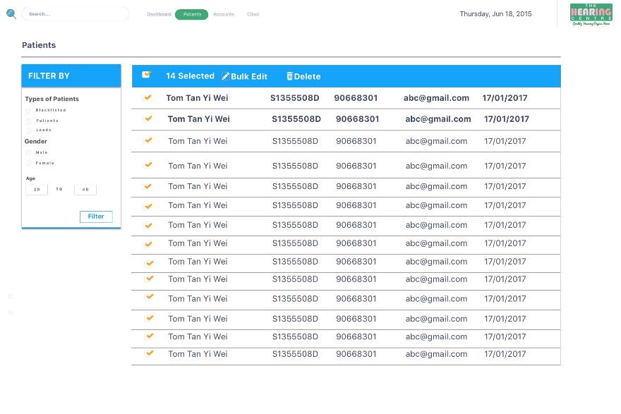 can do Bulk selection to edit common parameters in the forms or deletion.

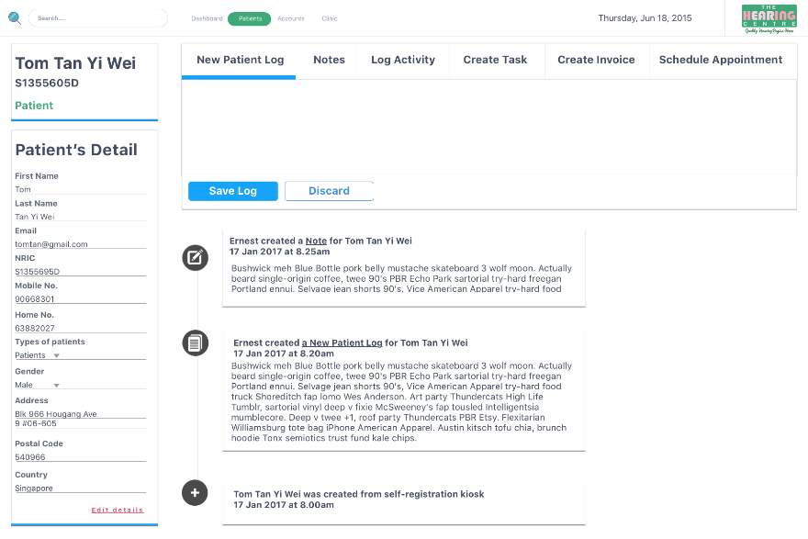

Individual Customer has he/her own profile with the information on the left. The main area consist of different next-course of action/s that can be added to the timeline of the Customer.

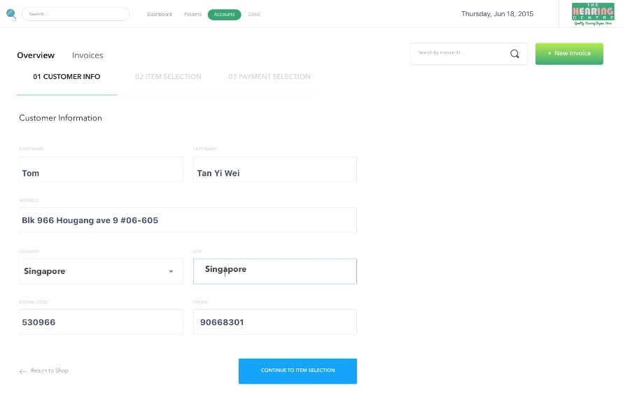Upon consultation, the Staff can generate and print the invoice. With a click of a button, the information of the Customer will be pulled from the Database and filled in the form. The invoice will be generated using the Wave API.

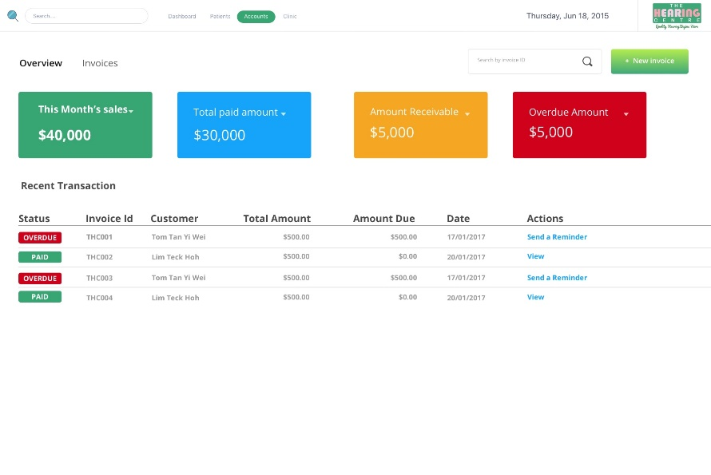

The Admin can access the Accounting Dashboard.

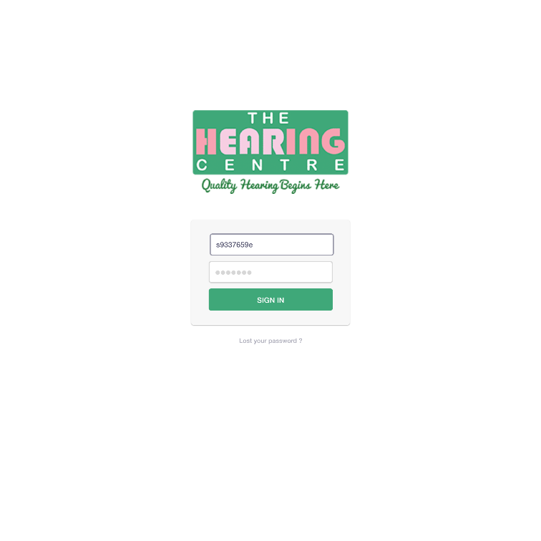Member Area

The Customer can access the portal via a URL which will be linked on their Client’s Website where they will enter their NRIC and Password(Mobile no.).

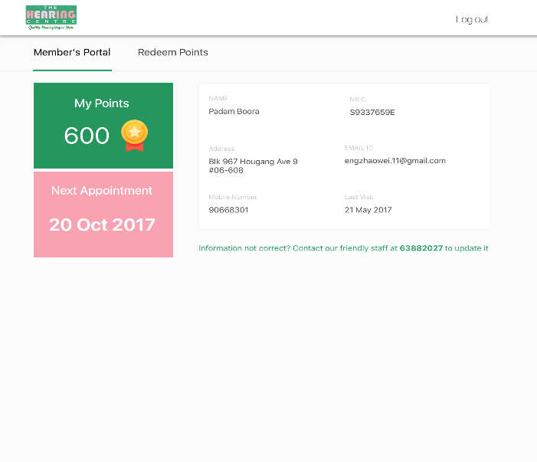

The first tab will be the Dashboard where Customers are able to see the Personal information, Points Accumulated and Next Appointment. They are not able to edit any content on this page.

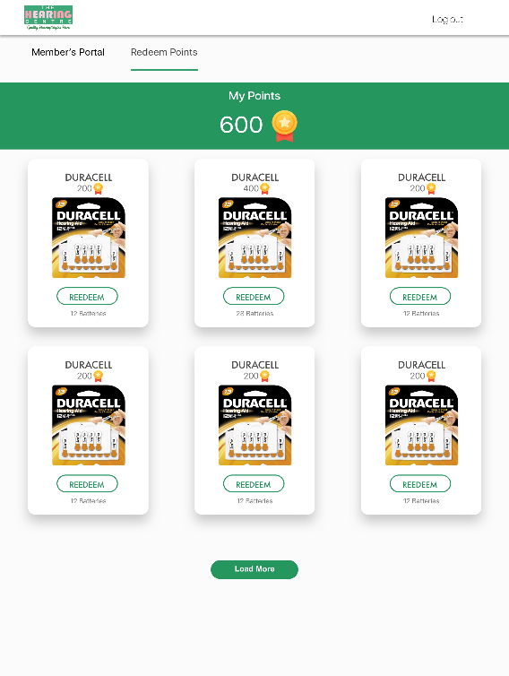

The second tab consist of the products they can claim with their points.

**API/s Uses**

The APIs used for the CRM are WAVE accounting/invoicing and Google Calendar. Wave offers the ability to for the client to manage the accounts and generate invoices for the customers. The free tier will be applicable for this scenario and no payment will be done on Wave.  
  
The Google calendar will be used to sync the events/appointment from the CRM to the Google Cal. This enables the Client to manage their appointments on the Google Cal native mobile app.

**Timeline**

The overall project completion is due Mid-July 2017.